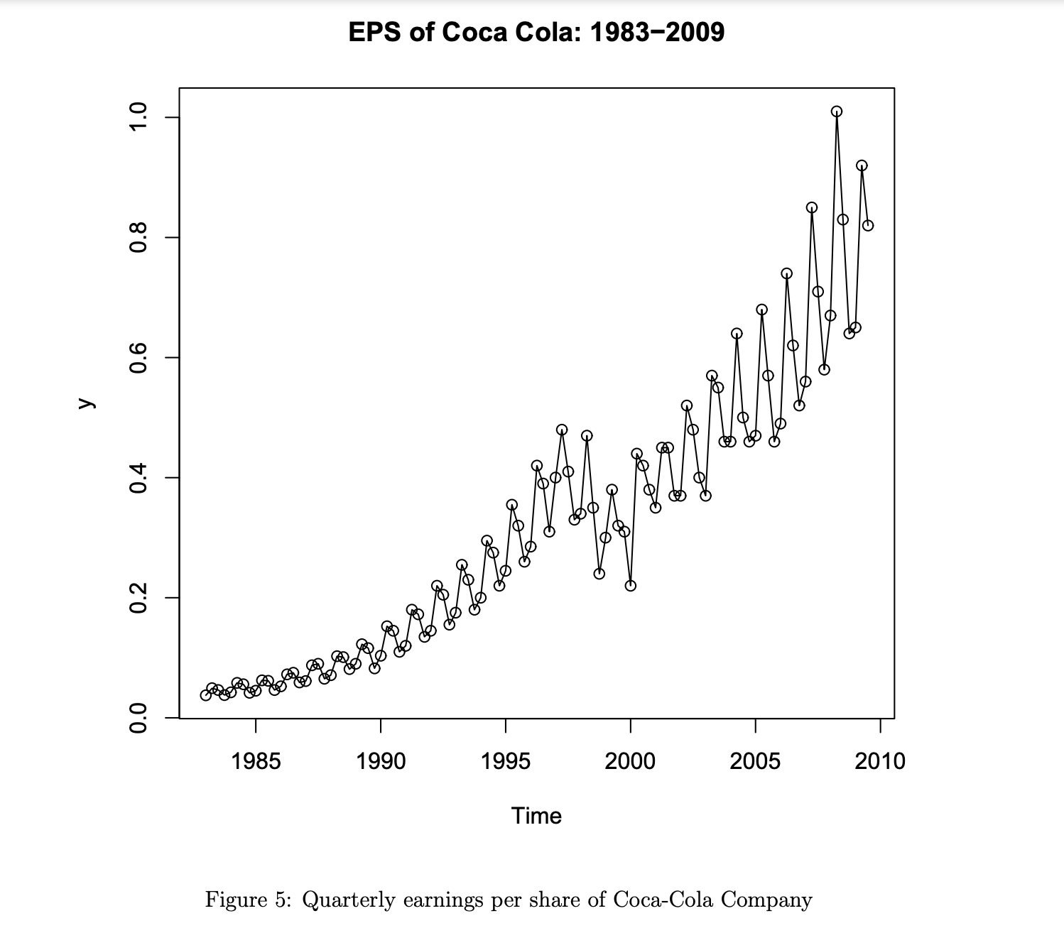

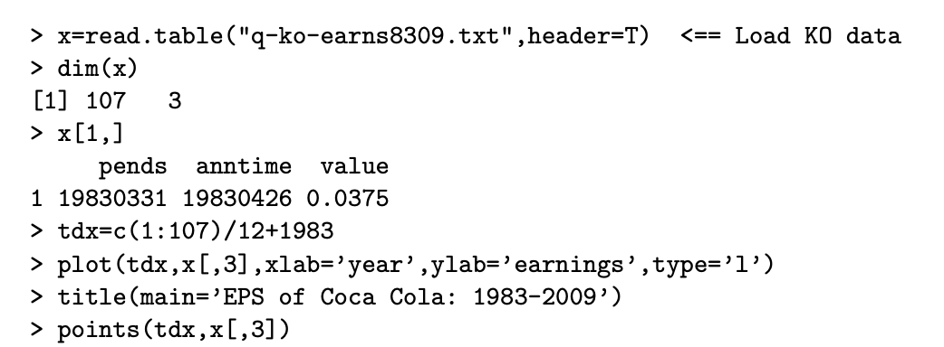

Below From https://edisciplinas.usp.br/pluginfile.php/2302398/mod_resource/content/1/TSAY%20-%20An%20Introduction%20to%20Analysis%20of%20Financial%20Data%20with%20R%20%282012%29.pdf

On the other hand, consider the quarterly earnings per share of Coca-Cola Company shown in Figure 2.2. If one divides the time span into few subperiods, the resulting sample means differ substantially from one subperiod to the other. Therefore, the earnings are not weakly stationary. This is not surprising because one would expect that the quarterly earnings of a good company increase over time. The time plot in Figure 2.2 also shows that the variability of the earnings increased over time. Therefore, the variance of quarterly earnings is also time varying. Consequently, the series of quarterly earnings is not stationary.

